 |  | Substation |  |  | HABU HEIGHT |  |  |  |  |  |  |  |  |  |  |  |  | Date: 01/06/2026
 |  | Equipment |  |  | LVDB2 TX1 |  | Manufacturer |  |  |  |  |  |  |  |  | ALGEBRA |  | Time: 5:38 PM
 |  | Model |  |  | J-SLOTTED |  | Rating |  |  |  |  |  |  |  |  | 1600A |  | Humidity: 77%
 |  | Area |  |  | OVERVIEW |  |  |  |  |  |  |  |  |  |  | Feeder No. |  | -
Feeder Name |  | -
 | IR IMAGE |  |  |  |  |  |  |  |  |  |  | VISUAL IMAGE
 |  |  |  |  |  |  |  |  |  |  |  | 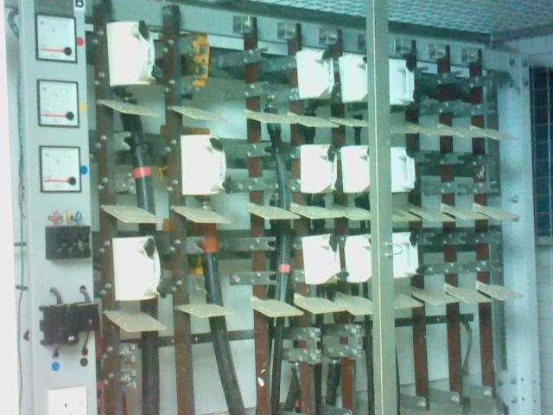
 | PARAMETER |  | VALUE
 | Spot Temp.1 (Sp1) |  | - |  |  |  |  |  |  |  |  |  |  |  | PARAMETER |  |  | VALUE
 | Spot Temp. 2 (Sp2) |  | - |  |  |  |  |  |  |  |  |  |  |  | Serial No. |  |  | LV2897
 | Average Temp. (Ar1) |  | 28.6 °C |  |  |  |  |  |  |  |  |  |  |  | Heater (A) |  |  | -
 | Ambient Temp. |  | 20.9 °C |  |  |  |  |  |  |  |  |  |  |  | CB Position |  |  | -
 | Delta T ( ∆ T) |  | - |  |  |  |  |  |  |  |  |  |  |  | Busbar Position |  |  | -
 | Load (A) |  | - |  |  |  |  |  |  |  |  |  |  |  | Cable Type |  |  | -
 | Defect |  | -
Analysis & Recommendations:

Analysis: No Anomaly.
Recommendation: -

